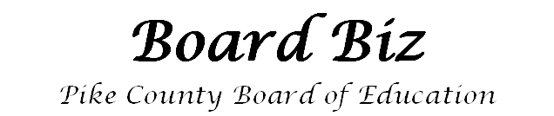 Highlights from the Board Meeting of December 12, 2016
UP TO THE MINUTES….

APPROVALS
- Approved Financial Statement and Bank Reconcilements for the month of November, 2016
- Approved payment of payrolls for the month of November 2016 and account run dates of 11/24/16 and 12/06/16
- Approved permission for Lisa Powell to attend the AL Music Educators Conference, January 19-20, 2017 in Montgomery, AL
- Approved permission for Wanda Corley, Lisa Powell, and Michelle Taylor to attend the AL Autism Conf., February 24, 2017 in Tuscaloosa, AL
- Approved permission for GHS to establish a Soccer Team
- Approved permission for Beth Chancellor, Pam Gardner, Tammy Calhoun, Ashley McManigle and Paul Kennedy to attend the Section 504 Conference, December 12-13, 2016 in Birmingham, AL

PERSONNEL MATTERS –
Changes/Additions
ALL SCHOOLS
Approved Family Medical Leave for Ansley Godwin
Accepted resignation of Charlie Harris, Bus Driver. Effective December 16, 2016
Approved employment of Lauren Campbell, Bus Driver
Approved employment of Marqueta Stewart, STEM Academy Teacher

BANKS SCHOOL
Approved a medical leave of absence for LaToya Gay

GOSHEN HIGH
Approved volunteer status for Ashleigh DeSandro, Girls Basketball

PIKE COUNTY ELEMENTARY
Approved employment of Donald Leonard, Music Teacher. Employment contingent on meeting requirements for ALSDE Certification

PIKE COUNTY HIGH
Approved employment of Nicholas James, Math Teacher. Employment contingent on meeting requirements for ALSDE Certification
Next Board Meeting

September 15, 2016
5:30pm
Board Members

Mrs. Linda Steed, President
Greg Price, Ph.D, V. President
Mr. Wyman Botts
Rev. Earnest Green
Clint Foster, Ph.D
Mr. Chris Wilkes

Our Purpose:

Clean and Safe Schools
Friendly and Courteous Service
Academic Accountability
Fiscal Responsibility

